

School Improvement Strategy

At the Soke Education Trust we have a core purpose and vision to ensure children sustain high achievement, explore the world they live in and are empowered to become confident learners. We achieve this by delivering excellent educational outcomes through a curriculum which enables children to learn important knowledge, skills and concepts so that they make meaning of the world and thrive within it.

We recognise that each school has its strengths and has much to celebrate and share. It is important to us that each of our schools retain their own identity, individuality and creativity but work in partnership to deliver a consistent approach, where we know this leads to best practice and excellent outcomes. Our school leaders and staff develop the individual character of their school so that they can best serve their local community.

All our schools are learning organisations who try new things, share experiences and learn from each other. However, to be most effective, initiatives need to be sustainable. We consider both what we need to implement as well as the impact of the change before adopting and embedding practice that works best. Based on this philosophy, our Improvement Strategy sets out how we will work individually and collectively with schools and their leaders.

Our school improvement strategy is based on:

- Providing high quality professional development for all staff to enhance their skills and knowledge
- Developing distributed leadership structures
- Establishing and achieving ambitious targets for all children
- Developing Quality First Teaching
- Ensuring provision is equitable
- Having high expectations for behaviour and attitudes and simple, clear systems to support this
- Supporting staff wellbeing
- Developing and delivering a curriculum that ensures an entitlement for all
- Implementing an appraisal system which is linked to continuous monitoring activities and professional development

Our improvement strategy has been shaped by our belief in collaboration and partnership and the principles of evidence-based interventions. Support is provided in a planned and systematic fashion to ensure it is embedded and sustainable.
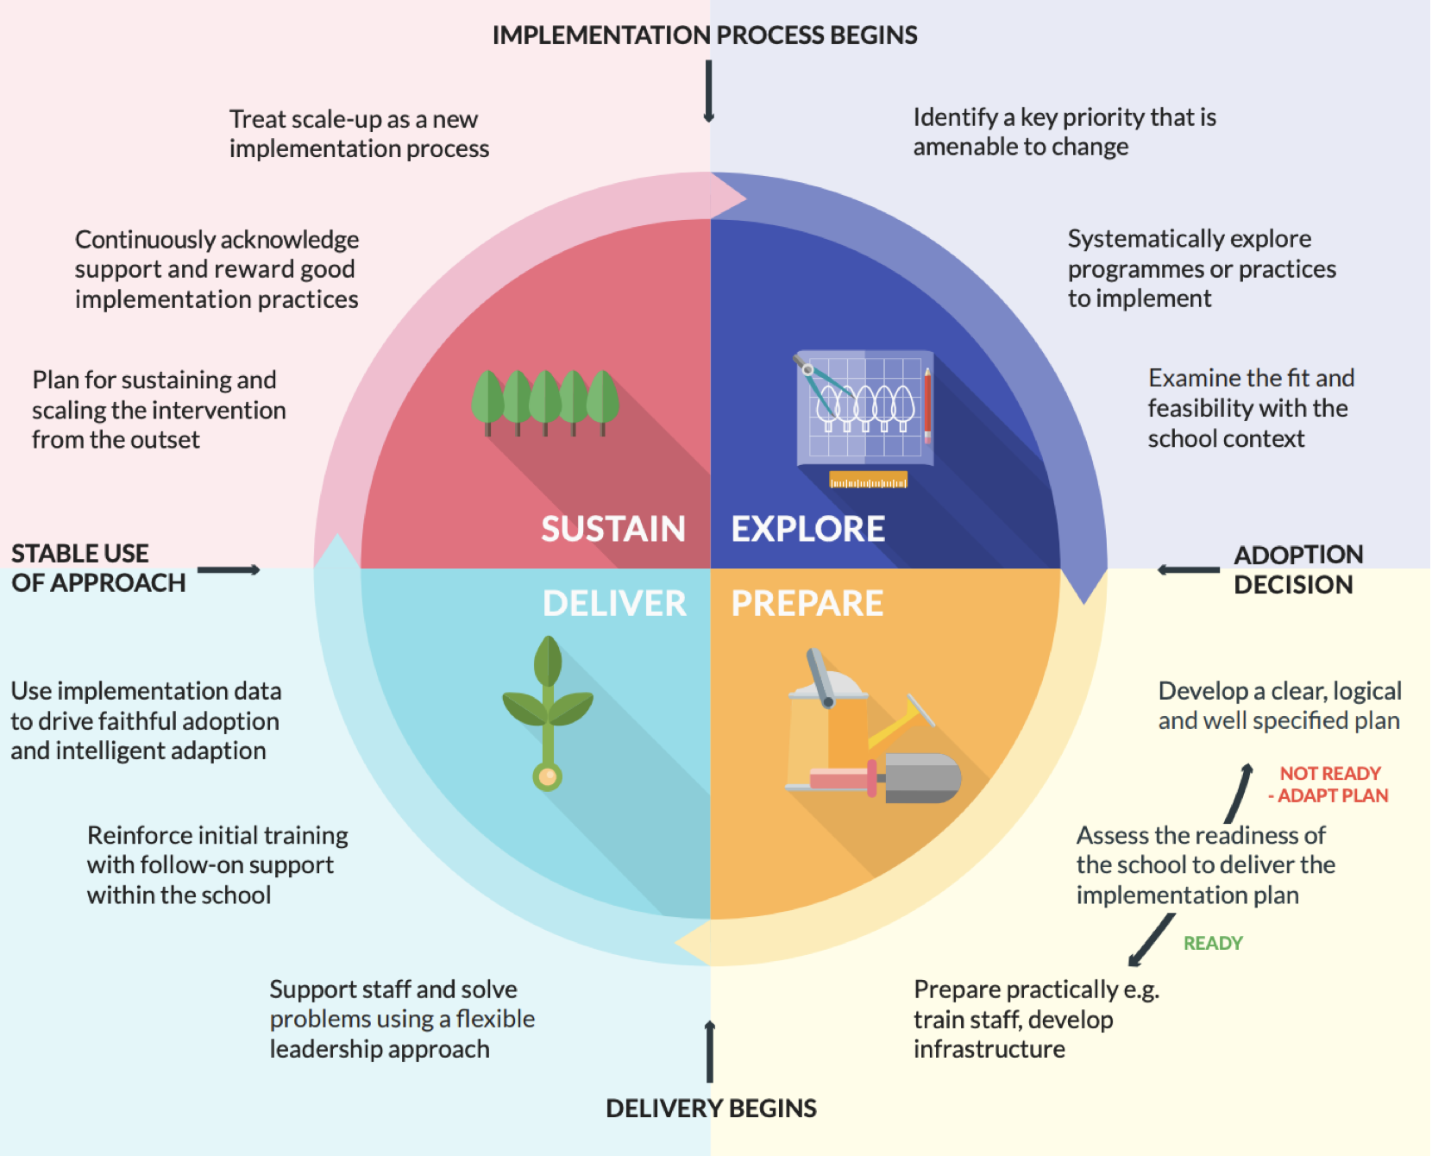

EEF Implementation Process

It is recognised that schools require support at different levels and at different times. Support is provided at four levels; sustain, refine, reinforce and stabilise. Where schools are successful and performing strongly it is important that they are able to operate autonomously, whilst sharing their good practice with others. Where a school finds itself in more challenging situations, the Trust will need to provide a higher degree of involvement to increase capacity, strengthen systems and secure rapid improvements.

Academic Support

Category | Descriptor | Key Features | Engagement
Sustain | A strong school with good capacity for its own improvement and can offer significant support in many areas to others in their improvement journey | Shares best practice across school & delivers school-to-school support within the Trust  Committed to developing excellent teachers  Leadership is distributed through the organisation  Develops practice based on research and evidence-based initiatives  Grows leaders at every level and plans for succession opportunities  Attainment and progress measures are likely to be consistently good and above average and improving over time | Participation in three weekly Headteacher Network meetings  Participation in termly Deputy Head & Subject Leader Network meetings  Termly progress meetings with CEO  Joint monitoring visit with CEO, termly  At least one half termly support session with Trust improvement service for coaching etc  At least one Trust training day
Refine | A school that is continuing to improve and has the capacity to support other schools in some key identified areas | Has the capacity to bring about improvement in their own organisation  Accurately self- evaluates  Leaders have a clear focus on what they need to achieve to become excellent  Leadership team consults and develops others  Provides some support to others within the Trust  Engages with some research/evidence-based initiatives  Attainment and progress measures are likely to be at least average and improving over time in all key phases | Participation in three weekly Headteacher Network meetings  Participation in termly Deputy Head & Subject Leader Network meetings  Termly progress meetings with CEO  Joint monitoring visit with CEO, termly  At least 2 sessions of support each half term from the Trusts School Improvement service  At least one Trust training day
Reinforce | A school that will benefit from additional support in its own improvement journey and does not yet have the capacity to provide support for other schools | Demonstrates capacity to bring about improvement or sustain improvement in key areas but has some vulnerabilities in key focus areas for example: leadership capacity and stability, attendance, curriculum intent and implementation, provision and outcomes for SEN pupils and/or external attainment/progress outcomes  Attainment and progress measures, are inconsistent and/or below average | Participation in three weekly Headteacher Network meetings  Participation in termly Deputy Head & Subject Leader Network meetings  Half termly Progress Meetings with CEO  At least 3 improvement support visits each half term from the Trusts Improvement advisor  Trust delivered staff training- matched to SIP  Termly quality assurance of pupil progress and attainment  External reviews if required including Governance, SEND and Pupil Premium  Support from schools across the Trust to secure improvement eg visits, leadership  External Consultant support in place to secure rapid improvement  At least one Trust training day
Stabilise | A school with significant areas of development and without the capacity to secure their own improvement | Attainment and progress measures in a number of phases are below average and showing no signs of sustained improvement  No clear and sustained focus on school improvement  No evidence of sustained improvement or capacity  Morale and perception of school is low – high staff absence, falling pupil numbers  Need to improve rapidly within a given review period  Inaccurate and overly generous self-evaluation | Participation in three weekly Headteacher Network meetings  Participation in termly Deputy Head & Subject Leader Network meetings  Monthly progress meeting with Chief Executive Officer, Chair of Governors  Head of School Improvement support in place to promote rapid improvement at least weekly visits  Secure effective senior leadership  Reviews of Governance, SEND and Pupil Premium  Implement a robust and rigorous School Improvement Plan and monitoring and evaluation schedule, underpinned by 6 weekly Rapid Improvement Plans  Ensure that leadership at all levels can bring about sustained improvement  Secure quality first teaching across the school using expertise from across the Trust  Rapidly raise standards of attainment and accelerate progress across the school  At least one Trust training day

Operational Support

Category | Descriptor | Key Features | Engagement
Sustain | A strong school with good capacity for its own improvement and can offer significant support in many areas to others in their improvement journey | Shares best practice across school & delivers non-academic school-to-school support within the Trust  Committed to developing excellent staff across all job families  Leadership is distributed through the organisation  Develops practice based on research and evidence-based initiatives  Grows leaders within every job family and plans for succession opportunities | Joint monitoring visit HT/CFO, termly - review Every/Risk Register  Monthly Operations Network meetings  At least one termly support session with Trust improvement service to identify areas for specialised support  Trust provided H&S training sessions through Every  Annual H&S audit from Trust Competent Person
Refine | A school that is continuing to improve and has the capacity to support other schools in some key identified areas | Has the capacity to bring about improvement in their own organisation  Accurately self- evaluates  Leaders have a clear focus on what they need to achieve to become excellent  Leadership team consults and develops others  Provides some non-academic support to others within the Trust in specialist areas | Joint monitoring visit HT/CFO, termly -review Every/Risk Register/action plan  Monthly Operations Network meetings  At least one termly support session with Trust improvement service focused on area for development  Trust provided H&S training sessions through Every  Annual H&S audit from Trust Competent Person
Reinforce | A school that will benefit from additional support in its own improvement journey and does not yet have the capacity to provide support for other schools | Demonstrates capacity to bring about improvement or sustain improvement in key areas but has some vulnerabilities in key focus areas for example: Organisational structure, financial situation, declining number on roll, lack of academic resources, building maintenance support | Joint monitoring visit HT/CFO, half termly - review Every/Risk Register/action plan  Monthly Operations Network meetings  At least half , termly support session with Trust improvement service to identify bids, H&S training, website compliance  Trust provided H&S training sessions through Every  Annual H&S audit from Trust Competent Person  Review of governance/governor training  Support to device marketing plan
Stabilise | A school with significant areas of development and without the capacity to secure their own improvement | No evidence of sustained improvement or capacity in key operational areas for example: Organisational structure, financial situation, declining number on roll, lack of academic resources, building maintenance support  Morale and perception of school is low – high staff absence, falling pupil numbers  Need to improve rapidly within a given review period  Inaccurate and overly generous self-evaluation | Joint monitoring visit HT/CFO, monthly - review Every/Risk Register/action plan  Monthly Operations Network meetings  Compliance review of the website  External Safeguarding & Site Audit  Integrated curriculum planning budget review - SMRA/CFO  Support to devise marketing plan  Targeted communication to stakeholders  Full Governance review & action plan

To categorise each school the Trust uses a risk matrix. The matrix is based on agreed key performance indicators for each school and is completed through the leaders self evaluation. Local governance committees use the Risk Matrix as part of their ongoing monitoring.

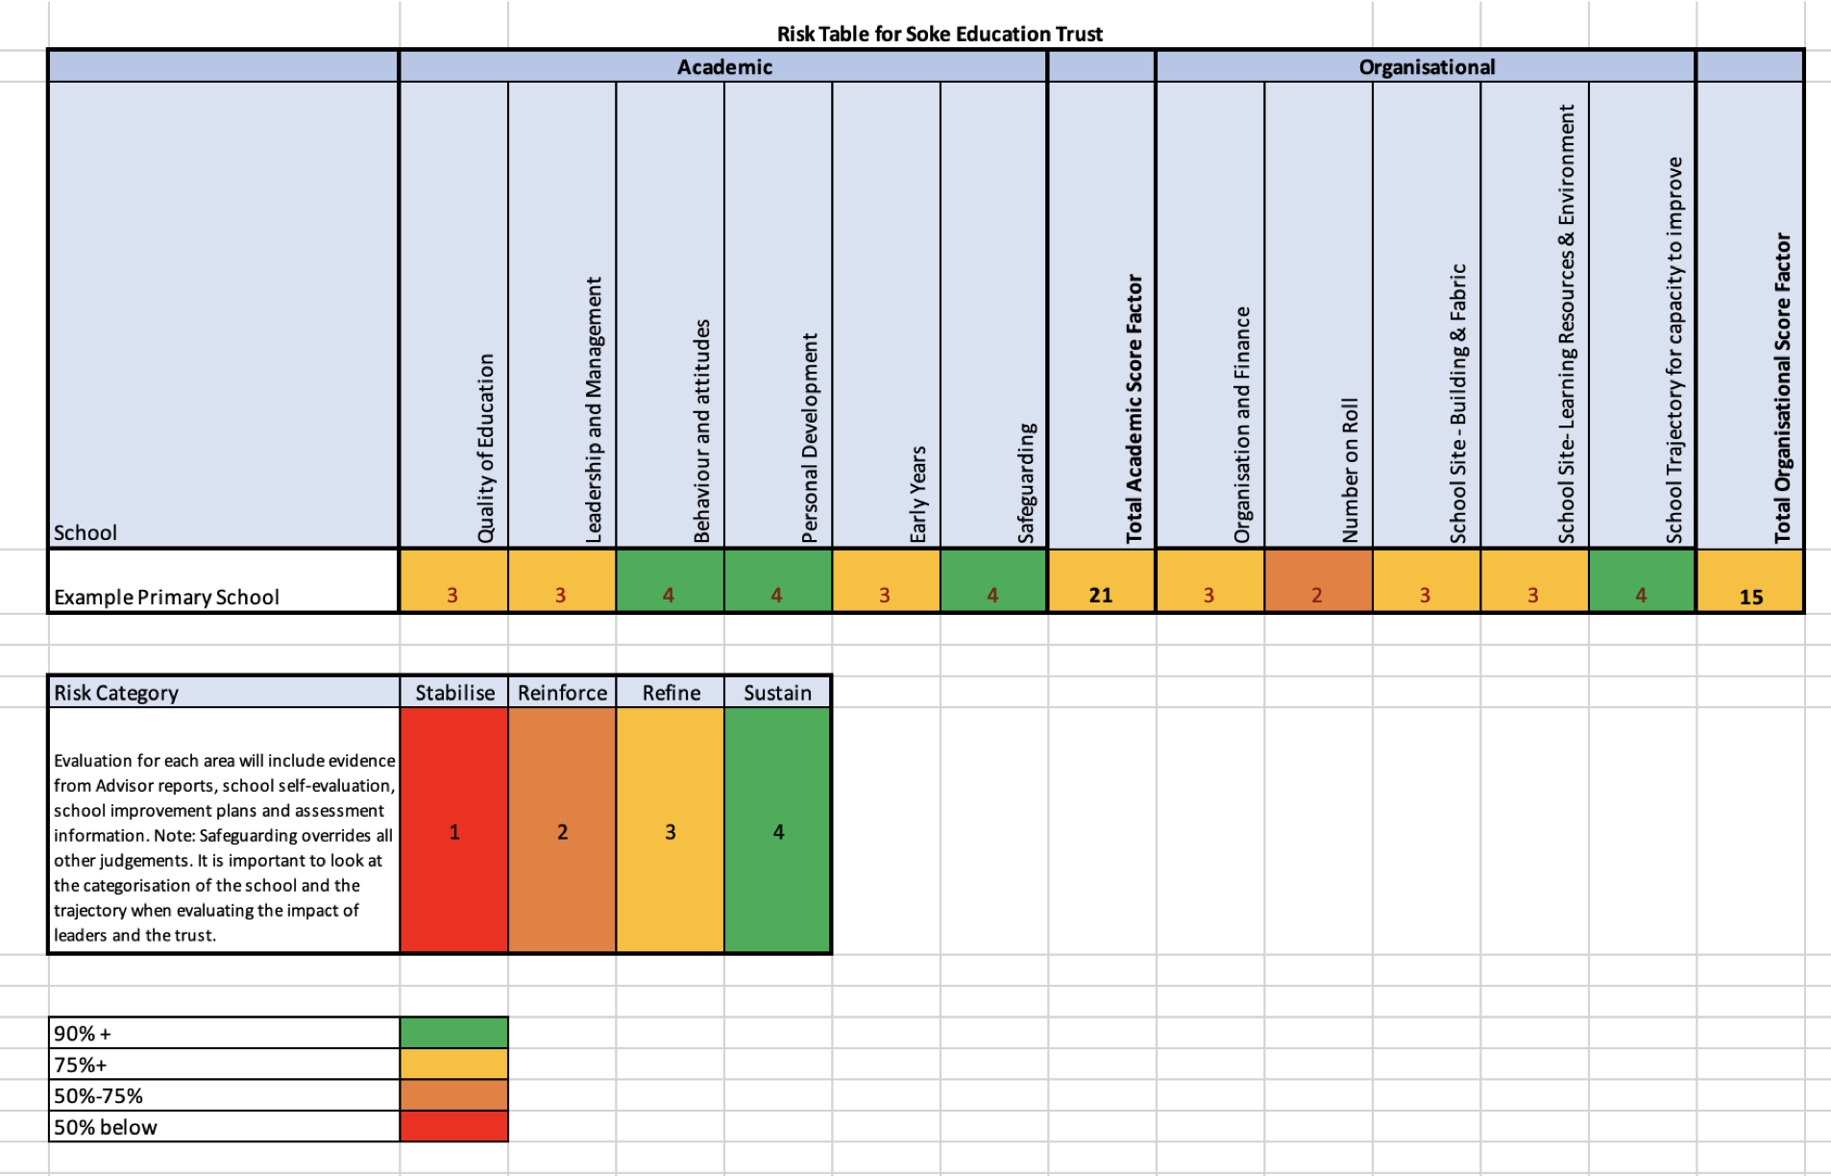

School Improvement criteria | Key performance Indicator
Quality of Education | - SEF/Ofsted judgement  - Clarity of curriculum intent  - Teaching Over Time Records  - Attainment & Progress (in-year PiXL benchmarking, national data, school level assessments)
Leadership & Management | - Risk level of leadership experience  - Risk factors affecting leadership (e.g staff absence)  - Quality of staff development  - Staff voice (CPD, wellbeing, workload)  - Staff absence rates
Behaviour & Attitudes | - Exclusion level in comparison to local and national  - Pupil attendance rates  - School Persistent absence v national data  - Bullying logs
Personal Development | - Pupil voice  - Access to experiences  - Use of pupil premium  - Transition between phases
Early Years | - Leadership experience  - Monitoring judgements of quality of provision  - GLD outcomes compared with National
Safeguarding | - S175 Audit  - Staff survey  - Single central record
Organisation and Finance | - Administrative efficiency  - Level of school finances (deficit/surplus)
School Roll | - Roll v PAN  - Level of declining roll  - Local context eg housing  - Marketing & Communication plan
School Site (Building/Fabric) | - Condition Improvement Survey  - Grading against Every risk matrix  - Knowledge of on-site support  - Risk Register
Learning Environment & Resources | - Quality of resources for curriculum implementation  - Quality of environment against Trust checklist
School capacity to improve | - Staff engagement in CPD  - Staff wellbeing survey  - Staff attendance  - Governance audit and skills

To provide a consistent basis for improvement the schools in the Trust have adopted common approaches to key aspects. This ensures that resources can be tailored for maximum impact.

Shared Approaches
Assessment & Target Setting | Use of FFT and prior attainment to set ambitious targets  Use of PiXL to assess learning in Year 1-6  Use of Insight Tracking  Use of No More Marking
Improvement Planning | Agreed School Improvement Plan (SIP) format  SIP quality assured by Head of School Improvement  Agreed SEF format  Agreed monitoring templates and approach
Pupil Premium | Agreed Strategy format  Agreed reporting format
Sports Premium | Agreed Strategy format  Agreed reporting format
Curriculum | Shared approach for curriculum Intent
Local Governance Committee | Common reporting template to ensure that the information provided for local governors is similar across the Trust and covers the necessary areas  Consistent agendas and minutes
Leadership Support | Access to the School Bus  EAP scheme  Regular networking  Common policies  Sentry digital SCR  Every Compliance

Effective and Impactful Monitoring

To ensure that monitoring of the quality of education is consistent and effective the Trust implement similar strategies

The purpose of monitoring

- To ensure that pupils are learning the intended curriculum:
- To check that teachers deliver the subject in a way that allows pupils to transfer key knowledge to long-term memory; and,
- To see if teachers present information clearly, promote appropriate discussion, check pupils’ understanding systematically, and identify misunderstandings and adapt teaching as necessary to correct these.
- We monitor to identify and share best practice and to provide support and continuous professional development to improve teaching, learning and assessment.
- We believe that long distance swimming is healthier than deep dives! This is because subject deep dives only provide a view at one point in time.
- Regular triangulated monitoring underpins a culture of school improvement based on a continuous learning approach.
- Our approach is a ‘a little but often’ strategy
- Monitoring is linked to the school’s teaching, learning and assessment framework.
- Monitoring builds up an accurate picture of teaching, learning and assessment over time – monitoring provides small pieces of evidence in a larger, longer-term picture.

To ensure a wide range of accurate evidence is gathered we triangulate the evidence base using:
- Data
- Pupils’ work
- Teachers’ planning
- Pupils’ views
- Observed teaching, learning and assessment.

This is analysed to ensure it is :
- reliable, accurate evidence
- Provides structured feedback with positive aspects links to the school’s teaching learning and assessment framework
- Contains areas of development for each teacher, year group, subject – with identified support and a date to check impact.

Monitoring strategies

Array monitoring

Monitoring of pupil’s learning can be effectively achieved by looking at book samples across a subject area. This method can provide evidence to demonstrate if children are progressing through the scheme of work with evidence of good quality learning, if there are adaptations to teaching the curriculum content which provide challenge and scaffolded support as needed and check if pupils are retaining and using knowledge in the longer-term.

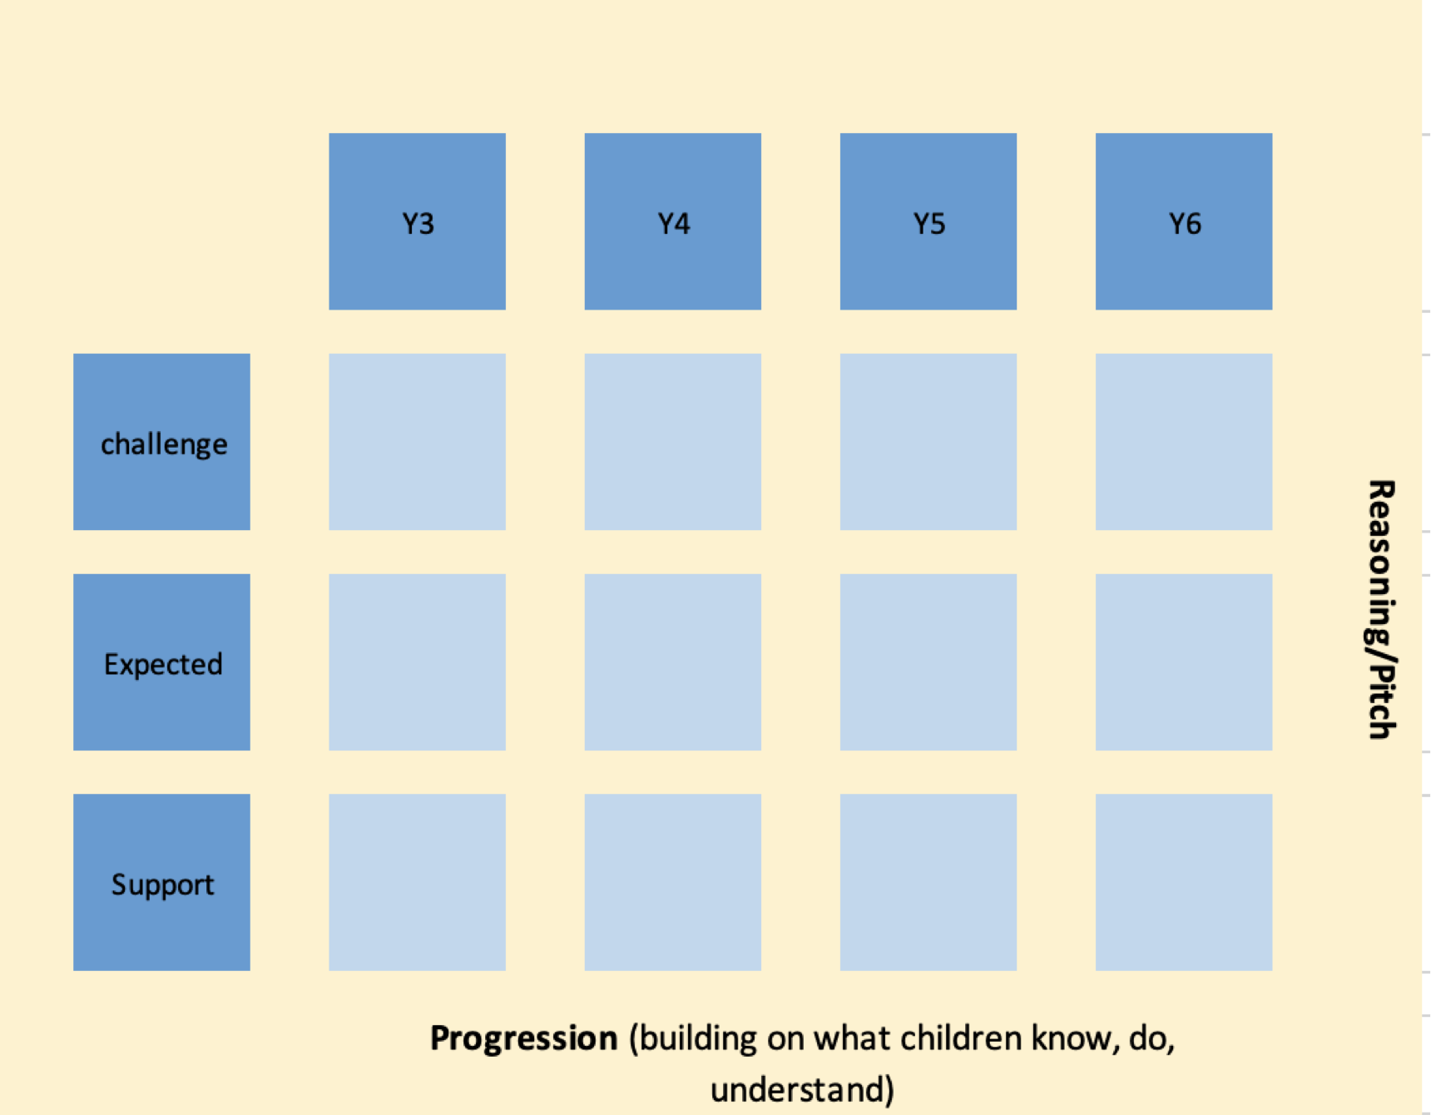

To carry out array monitoring:

- Set books out as in A (above) – this can be for a key stage or all year groups. It is important to link the monitoring to a discussion about, and visit to, Early Years to understand how your subject is taught within the curriculum for Nursery and Reception children and the transition into Year 1.
- Record all evidence and next steps using the monitoring form

Specific questions may include:
- In each class/year group are there high expectations as shown in pupils’ work (presentation, handwriting, quality and quantity of work)?
- Does the work in books match the scheme of work?
- Is there clarity about the sequence of learning (knowledge, skills and concepts) for each year group?
- Are all learners interested in the learning activities?
- Is there evidence that pupils are developing specific knowledge, skills and concepts in the subject?
- Are reading and writing well taught?
- Do learners understand how to improve their work?
- Is there evidence that all learners are making progress and achieving well (gains in knowledge, skills and understanding).

Class level work scrutiny

Examples of evidence that can be gathered using key qualities/criteria:

- Teachers have consistently high expectations of pupils (shown through planning, subject knowledge, exciting engagement, links with previous/future learning, level of challenge, behaviour of pupils).
- All learners are challenged (questioning, learning activities).
- Teaching extends and supports pupils’ learning (subject/curriculum knowledge, questioning, learning how to learn).
- Teaching is altered due to ongoing assessment (questioning, monitoring, discussion, peer review).
- The teacher is skilled at adapting the teaching of the subject to build on what pupils already know and so all pupils successfully access learning.
- Pupils demonstrate their understanding (especially of basic skills).
- Reading, writing, communication and mathematics are well taught (discretely and across the curriculum).
- Learners understand how to improve their work (marking, feedback).
- All learners make progress and achieve well (gains in knowledge, skills and understanding).

Specific questions for class or Year group work scrutiny may include:

- What adaptations are made to ensure SEND pupils can access all learning?
- Is there evidence that more challenging questions are asked for pupils who are demonstrating a good understanding of the subject?
- Record evidence and for each class/year group start developing helpful next steps to improve teaching, learning and assessment.
- Analyse the evidence and draw together key points for SLT on strengths and areas of development in the subject

Pupil Lesson Study

One of the many advantages of pupil lesson study is that it gives us a window into the lived experiences of pupils and reflects professional practice. This strategy helps to inform leaders:
- How well the curriculum structure supports pupils learning
- What knowledge is planned and taught
- How effectively vocabulary is planned and taught
- How well teachers explain and model content
- What sort of tasks pupils undertake
- The types of effectiveness of feedback and how well pupils understand and respond to it
- The range and reach of questions
- The use and impact of retrieval practice

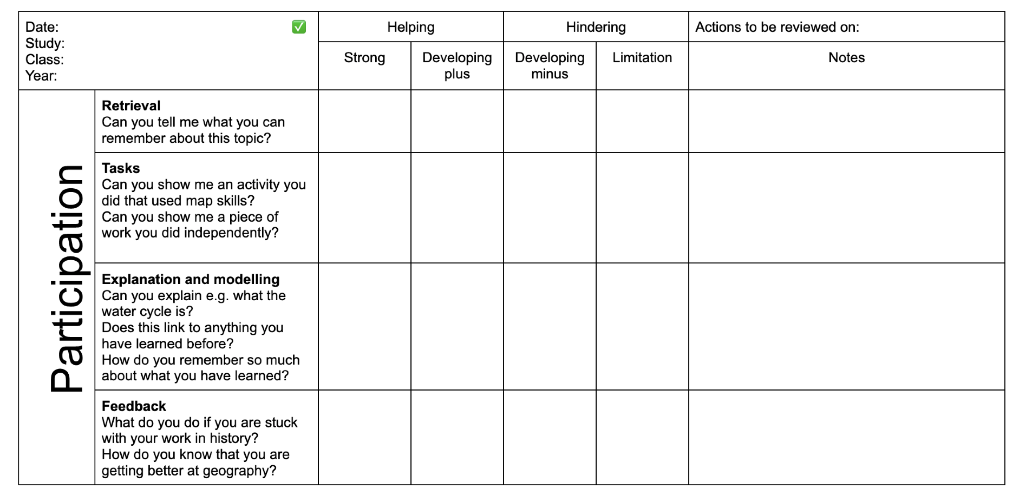
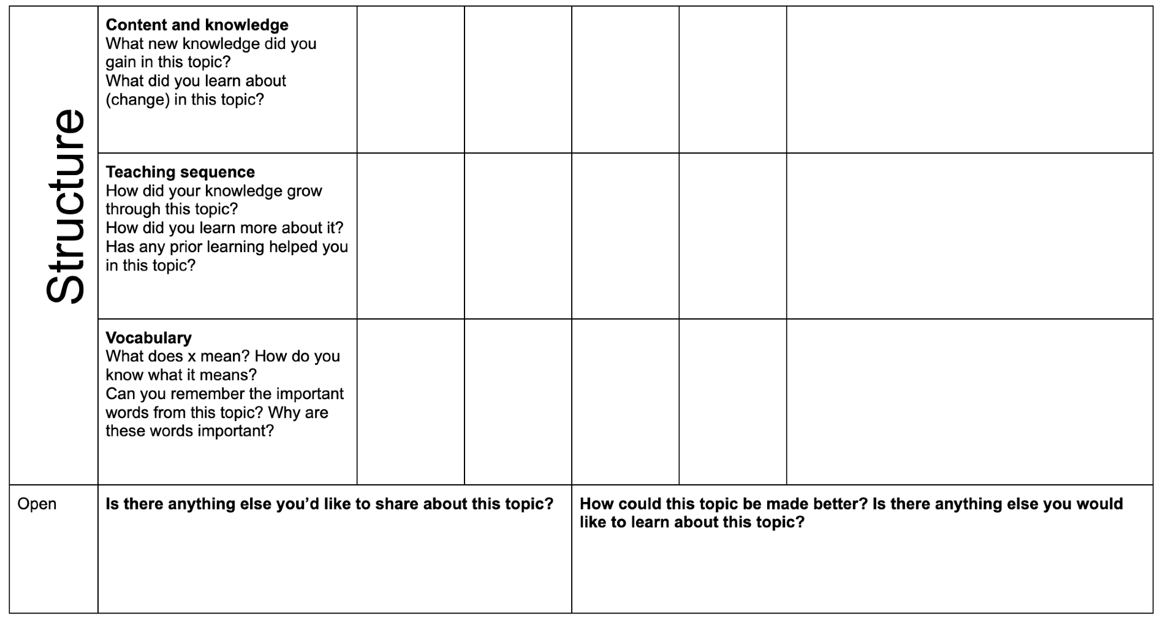

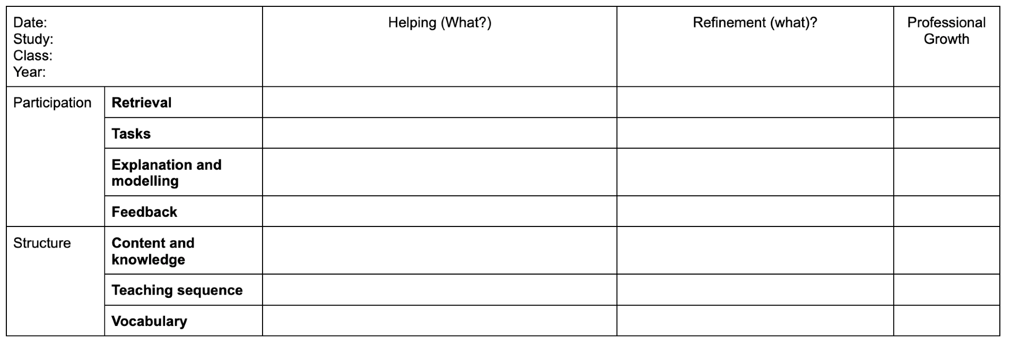

Monitoring Form

Example of a monitoring form, demonstrating evidence, next steps and recommendations to SLT.

Focus: Science |  | Date: 29/04/22
Method – circle as needed (planning, work scrutiny, learning walk, pupil voice, observations, data, questionnaire, other - Work Scrutiny (array method)
Monitoring lead:
Class/Year | Evaluative comment |  | Required actions to address development needs
3 | - Emphasis on practical work  - Clear framework for teaching pupils how to be scientists (hypotheses, experiments, conclusions)  - Good formative assessment involving pupil self-review and teacher marking.  - Good next step marking and effective feed back  - Pupils have opportunities to carry out fair tests and experiments  - Summative assessment is used and there is evidence of gap analysis  - Y3 curriculum is covered well.  - Some examples of scaffolded support for pupils who need support  - There is evidence of pupils progressing is key science skills such as carrying out a fair test  - Use of outside experts |  | - Provide opportunities to revisit experiments and adjust accordingly.  - Consider how to provide greater challenge for the most able pupils
4 | - Highly effective feedback with responses from pupils.  - Formative and summative assessment are evident throughout  - Coverage  - Good examples of practical learning but not as many as Y3  - Increased expectations as the year progresses  - Some scaffolding for pupils who need support  - More able pupils are linking conclusions to hypotheses with good use of technical language |  | - Further focus needed for middle ability children on reasons why and drawing together conclusions  - Record practical learning using photographs
5 | - Effective planning  - Summative assessment is up-to-date  - Good feedback from teachers and responses to it  - The best work is linked directly to the curriculum and what it is to be a scientist  - Good emphasis on practical but not all work is recorded  - Some scaffolded support for more able pupils  - Evidence of progression from Y4 in knowledge but skills work is not always recorded |  | - Too much reliance on published worksheets – these constrain pupils, especially those who are more able  - Record all practical work in books (photographs) including an explanation and review
6 | - Focus on research  - Good links with ICT (e.g. PowerPoints explaining knowledge)  - Summative assessments up-to-date  - Formative assessment in place – the best provides next steps which are responded to  - Evidence of progression from Y4 (electricity)  - Good cross curricular evidence  - Emphasis on partner work and group work which provides support to key pupils  - Evidence of extension for more able |  | - Further develop self and peer review  - More opportunities are needed for pupils to be engaged in practical work devising their own experiments  - Consider how to scaffold support for pupils who need extra support.
Recommendations to SLT
- Consistent approaches to formative and summative assessments
- Need to record all practical work
- Develop self and peer assessment with older pupils
- Ensure there is clarity about how to record experiments in books with time to develop conclusions and return to experiments when needed
- Teacher planned work is superior to commercial worksheets
- There is evidence of good progression across KS2

Considered by SLT on ___________________ with the following agreed actions including altering the raising achievement plan where needed:
- Staff meeting:
  - Ways of ensuring there is practical work in all science lessons
  - How to record experiment – school approach
  - Revisiting conclusions and hypotheses.
- Reinforce the scheme of work using learning passport approach

