NRS Blog

Elaine Crane is Director of Education at Soke Education Trust, a MAT of 6 primary schools in Fenland and East Cambridgeshire and is also an Evidence Advocate for the Fenland and East Cambs. Evidence Network. Elaine is passionate about professional development and curriculum design as key drivers for school improvement.

From Review to Action: Using OFSTED’s research review series to inform curriculum and assessment in Art and Design

Why use the research review series to inform work in schools?

The OFSTED research review for Art and Design is considered essential reading by many evaluating or developing their Art and Design curriculum. The review draws on academic research papers, research from the EEF, PISA, the DfE and OFSTED itself and teacher-authored blogs; included is a synthesis of OFSTED’s own reporting on Deep Dives in Art and Design. Research was filtered through several lenses to ensure the aims of the review were achieved: an understanding that curriculum is different from pedagogy; how people learn and, in particular, cognitive science; relevance to inspection; subject specificity; what will achieve the aims of subject education.

The following table from the EEF’s guide to Using research Evidence, shows that the range of evidence reviewed is relevant and broad.

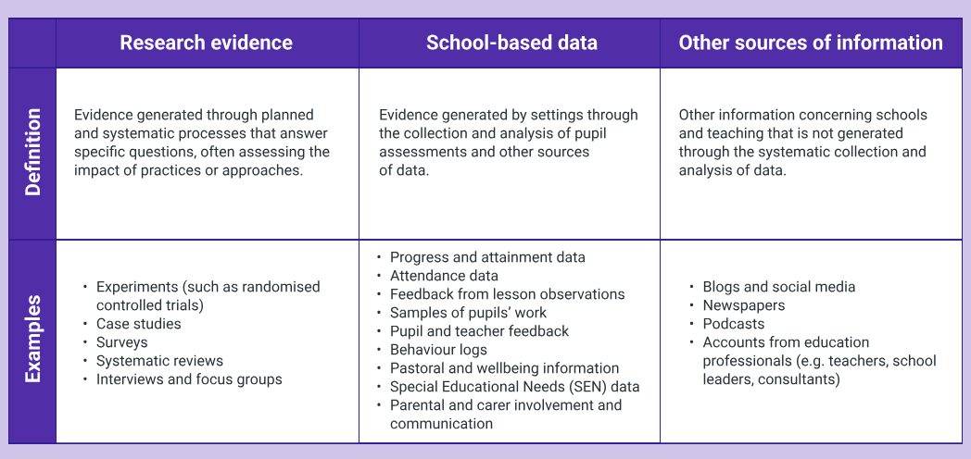

Combining research like this, as noted in the EEF guide, is useful to build a ‘rich evidence picture by considering a range of sources to identify themes and trends, as well as to better understand whether or not approaches could work in your specific school or context’: this last endeavour is the main motivation for accessing the reports and using them to inform Soke Education Trust’s work around curriculum.

What might be the pitfalls of using this research?

The EEF guide also prompts us, when considering using research, to consider what is being asked for and its purpose. It is therefore important to consider that while OFSTED hopes that the reviews will ‘support and inform those leading the thinking on subject education in our schools’, the series has ‘relevance to inspection’ as one of its filters. We would need to be careful to maintain focus on the Trust’s vision for its curriculum, which itself was built on an evidence-based approach, while using the synthesis of the valuable evidence outlined in the OFSTED review to inform decisions.

How was this useful when reviewing the Trust’s approach to Art and Design?

The Trust’s intent for curriculum is to enable pupils to make meaning of the world and thrive within it by learning the core concepts and knowledge within each subject: engagement with ‘big questions’ based on conceptual understanding is key to this. This is aligned to findings of the review, where ‘knowledge’ in art refers to ‘what pupils learn in art…. including concepts and/or principles.’ This includes:
- practical knowledge, such as how to mix colour and understand concepts like shape and form;
- theoretical knowledge, such as how and why artists choose to use a particular colour or composition;
- disciplinary knowledge, such as interpreting and valuing art.

These domains lead us to the ‘big questions’ that are important, such as ‘How do artists use colour to demonstrate feelings?’ or ‘Why do some Impressionist artists use visible brush strokes?’. They are also useful as strands to form a broad art curriculum that enables children to develop their artistic competence and style, underpinned by a strong understanding of what it is to be an artist.

How was this useful in forming a rationale for assessment in Art and Design?

Thinking of art in terms of practical, theoretical and disciplinary knowledge has been most useful in the thorny area of assessment in art and design. We view assessment in two different ways: firstly, how pupils’ knowledge and use of techniques has progressed - whether they can now state the primary colours, if their use of shading is more developed - and secondly, how they have creatively used their increasing understanding of art to inform their own work. It is important to acknowledge that this last judgement bears no relation to the perceived ‘quality’ of the final piece.

The review states that ‘It is important for leaders and teachers to recognise that defining the knowledge that pupils need to learn through the curriculum is not the same as restricting or prescribing the artwork they produce.’ and that children’s artwork ‘may be unexpected, unpredictable or unanticipated.’ - considering how practical, technical and disciplinary knowledge has progressed is useful to pupils and teachers, however saying that one piece of art is ‘better’ than another is not.

How has the research evidence informed practice?

The EEF’s guidance states, ‘for improvements to be made, we need to actively apply research evidence by making changes to what we do.’ The research informed our Trust model for assessment in Art and Design, illustrated in the following graphic.

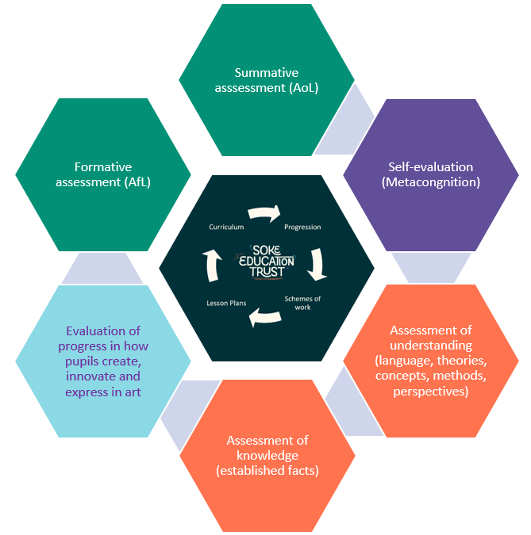

As indicated, central to this is the planned curriculum. Impactful assessment begins by planning with the end in mind and while within the Trust, the curriculum is designed as the progression model, we cannot assume that this means all learners progressing through it will learn the specified knowledge. Our model, informed by the findings of the OFSTED review, enables us to be methodical and specific when both planning and assessing Art and Design.

Sources:

EEF, (10 January 2024). Using research evidence: A concise guide

Gov.uk, (30 March 2021). Research and analysis: Principles behind Ofsted’s research reviews and subject reports

Gov.uk, (22 February 2003). Research review series: art and design

