GENDER PAY GAP REPORTING 2025
Introduction
Soke Education Trust employs over 250 employees and is required by law to carry out Gender Pay Reporting under the Equality Act 2010 (Specific Duties and Public Authorities) Regulations 2017. This is the second year that the Trust has undertaken Gender Reporting and this report details our latest results and makes a comparison to the previous year.
We are required to publish our results on the Trust website and the relevant government website. https://gender-pay-gap.service.gov.uk/
The Gender Pay Gap does not cover the requirement of paying men and women equal pay, which the Trust has a legal obligation to guarantee to every employee. The Trust uses national pay policy to meet this requirement. This report focuses on the difference in average earnings across our employee pay data range.
How we measure Gender pay
To understand our gender pay data, there are different measures we are required to use:
- Quartile pay bands: The proportions of male and female employees in the lower, lower-middle, upper-middle and upper quartile pay bands based on their hourly pay rate.

- Mean gender pay gap: The difference between the mean hourly rate of pay of male and female employees

- Median gender pay gap: The difference between the median hourly rate of pay of male and female employees
There are also legal requirements around reporting on bonus payments. However, the Trust has not paid any bonus payments over the period 1st April 2024 to 31st March 2025 so this will be a nil return.
We can use the gender pay results to assess:
- The balance of male and female employees at different levels
- The levels of gender equality in our workplace
- How effectively talent is being maximised and rewarded.
Gender Pay Reporting requires our organisation to make calculations based on an employee's declared gender. We established this by using our existing HR records. All employees can confirm and update their records if they choose to by contacting the Trust HR team.

Quartile Pay Bands
Using our snapshot data information at 31st March 2025 our workforce of 278 employees can be broken into the following gender profile across the national quartiles:
Hourly pay quarter | Female Headcount | Male Headcount | Female % | Male %
Lower | 65 | 5 | 92.86 | 7.14
Lower Middle | 67 | 2 | 97.1 | 2.9
Upper Middle | 59 | 11 | 84.29 | 15.71
Upper | 61 | 8 | 88.41 | 11.59
Total | 252 | 26 | 90.65 | 9.35

In comparison to last year we have reduced our headcount across the Trust from 287 to 278 employees. While our overall headcount has reduced, our male headcount has increased from 23 to 26. Out of this increase, most notably we have seen 2 extra males within the lower pay quartile.
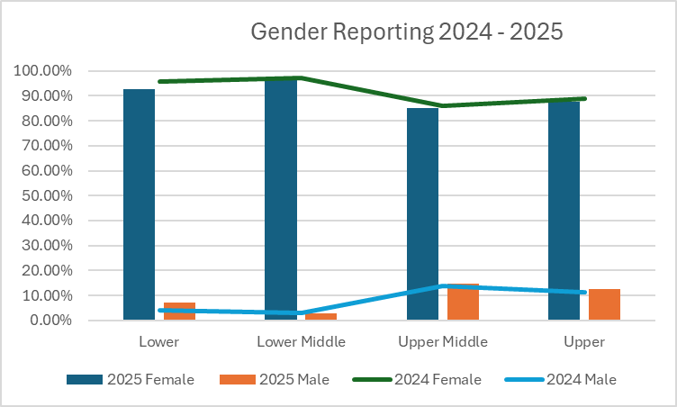
Mean Gender Pay data
This year we continue to have imbalance as follows:
Gender | Mean Gender Hourly Rate | Mean Gender Hourly Gap Percentage
Female | £19.79 | 14.70%
Male | £23.79 | 14.70%

On a positive note, in comparison to last year we have seen an improvement in our gap from 21.1% to 14.7%. The increased representation of male employees in our lower two quartiles has aided this improvement.
Medium Gender pay data
Gender | Median Gender Hourly Rate | Median Gender Hourly Gap Percentage
Female | £14.76 | 21.1%
Male | £18.70 | 21.1%

In comparison to last year we have seen an improvement in our gap from 31.5% to 21.1%.
Results / Highlights from the data analysis
On analysing our data, we have found the following key highlights:
- 90.65% of the Trust workforce is female and 9.35% is male. Our male workforce has increased from the previous year’s statistic of 8.01%.

- Female employees make up a higher percentage of the workforce, reflected across all four quartiles. This is indicative of the education sector as a whole where nationally there is a considerably higher distribution of female to male employees across all the quartiles. The majority of our male workforce are teachers which sit within our upper middle quartile where we have 15.71% male representation.
- The Trust has more female employees working in the lower quartiles of the organisation. This pattern is reflected in the make-up of the Trust’s workforce, with the vast majority of employees undertaking Cleaner, Lunchtime Supervisor and Teaching Assistant roles being female. The gender pay gap is a result of the roles in which males and females predominantly work within the organisation and the salaries that these roles attract.

- Largely due to the increase in male headcount in our lower pay quartiles our gap has reduced this year.

- The Trust has strong female representation across our Senior Leadership Teams in all schools.

Bonus Payments
The Trust has not paid any bonus payments over the period 1st April 2024 to 31st March 2025 and therefore there is no requirement to report on the measures related to bonus payments.
2024 Action Plan Review
Soke Trust is committed to gender equality in the workplace, and reducing the gender pay gap is an important measure for the Trust. The Trust believes in opportunities and equal treatment for all employees, regardless of gender or any other protected characteristic. To assist with ensuring we meet our commitments in this area we set an action plan last year. One key point of this was to monitor our recruitment around gender. We have used Mynewterm for all recruitment undertaken during the last academic year to ensure we reach all potential candidates equally. We have advertised 42 jobs which have attracted the following pool of applicants and successful candidates:
Gender | Applicants | Recruited
Female | 89.6% | 90.2%
Male | 9.9% | 9.8%
Prefer not to say | 0.3% | 0%
Transgender | 0.3% | 0%

The applicant data mirrors our current workforce data in that nearly 90% of all applicants are female. When we look at the successful candidates we see a correlation.
As a Trust we also committed to collecting exit survey data. We introduced a central monitoring point in the last academic year and reviewing this data has shown that the one male who has responded with a reason for leaving was a career break. The results of the survey have not highlighted any local issues linked to lack of progression, pay due to gender or equal pay concerns.
2026Action Plan
As a Trust we aim to:
- decrease the gap further
- focus on addressing occupational segregation through recruitment, career development and challenging stereotypes
- acknowledge that our position reflects sector wide patterns whilst still taking action to improve diversity and opportunity within our Trust
To achieve this, we will commit to the following plan for the next year.
  - Ensure we have open and transparent recruitment advertising to encourage a wide range of diversity of applicants:
    - We will review recruitment materials for support roles to ensure gender neutral language and imagery
    - We will monitor recruitment data including applications based on gender.

- Ensure we implement fair, safe and effective hiring practices:
  - We will ensure relevant members of staff undertake recruitment training prior to taking part in the interview panel which will include unconscious bias training.
  - We will endeavor to have a mix of panel members and experience where possible

- Ensure we maintain and promote comprehensive family friendly employment practices to support workforce retention, well-being and work-life balance:
  - We will ensure flexible working opportunities are accessible and well-communicated
  - We will continue to provide enhanced maternity pay and ensure fair treatment of staff on maternity leave
  - We will support shared parental leave and ensure fair treatment of staff on shared parental leave

- Continue to maintain a systematic approach to effectively utilise staff exit survey data to understand their reason for leaving and experiences working at our Trust
  - Monitor staff exit surveys for any trends/reasons for leaving and include gender analysis.
  - Share findings of monitoring and analysis with relevant stakeholders with suggested action to take to drive meaningful improvements in retention, equality and staff well-being
  - Integrate exit data into broader equality and retention strategies by using it to inform our equality objects and action plan, using it alongside other workforce data and include in succession planning

- We will maintain a systematic annual process to meet legal requirements and address pay inequalities:
  - We will undertake the Gender pay audit, as per our legal requirement, on an annual basis
  - We will build comparison for year-on-year data
  - We will continue to monitor outcomes to see if trends emerge and understand where and why a pay gap may exist
  - We will continue to develop and implement an action plan. Although we are not required to publish an action plan, it will demonstrate our commitment to gender equality in the workplace to current and potential employees.

January 2026

